**TASK 4**

**My RSP Sandbox Journal**

My Name:- Shrutika Atul Sakarkar

This Is all about my journey started and ended in working with RSP Sandbox.

I have done a 2 projects as follows:

1. Create a to do list web app.
2. Create a Simple Calculator.

Now in to do list web app:

I was Languages like html and javascript.. In that I had used some function in javascript. My snippeds of code.is like.

Html:-

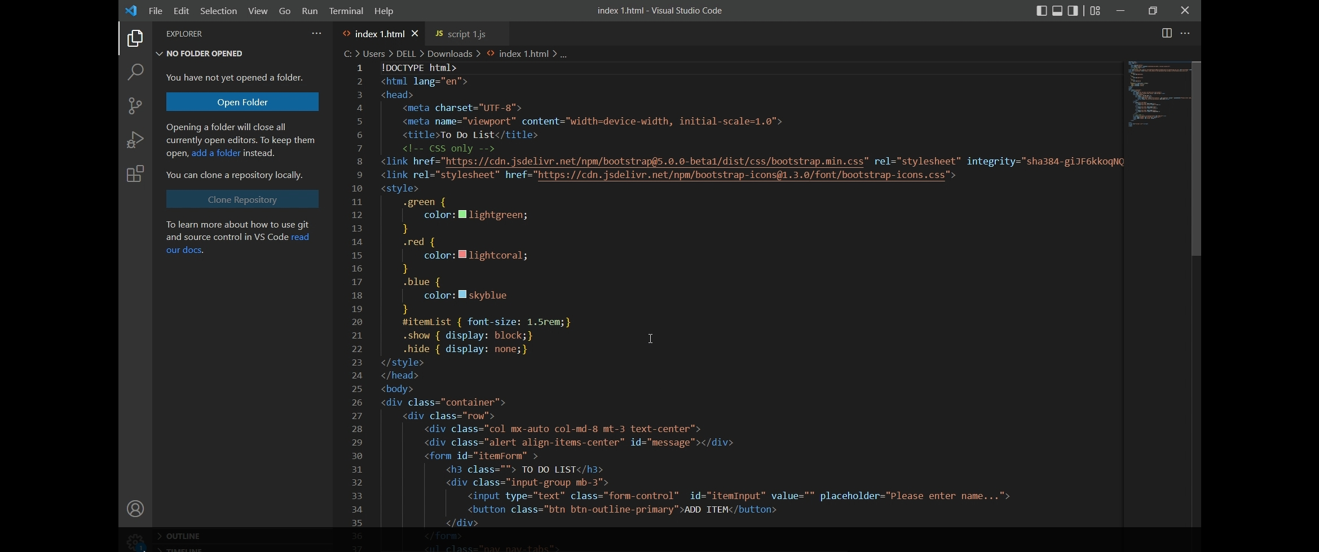

javascript:-

only some part of code is shown here.

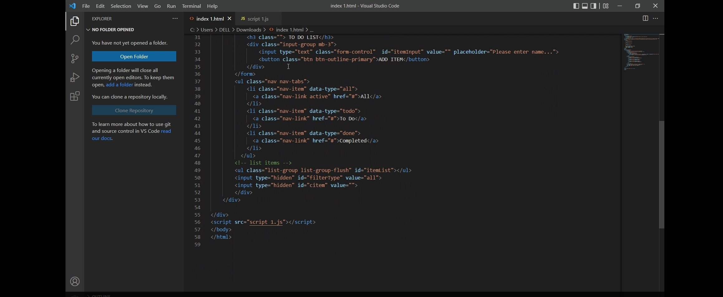

Output:-

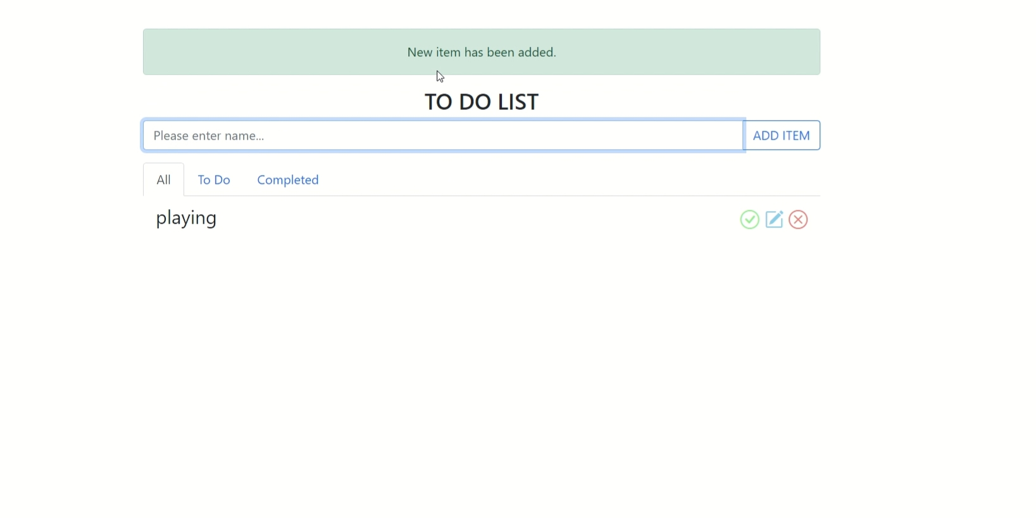

So in Calculator:-

I used Languages like html css and javascript.. In that I had used some function in javascript. My snippeds of code.is like.

Html:-

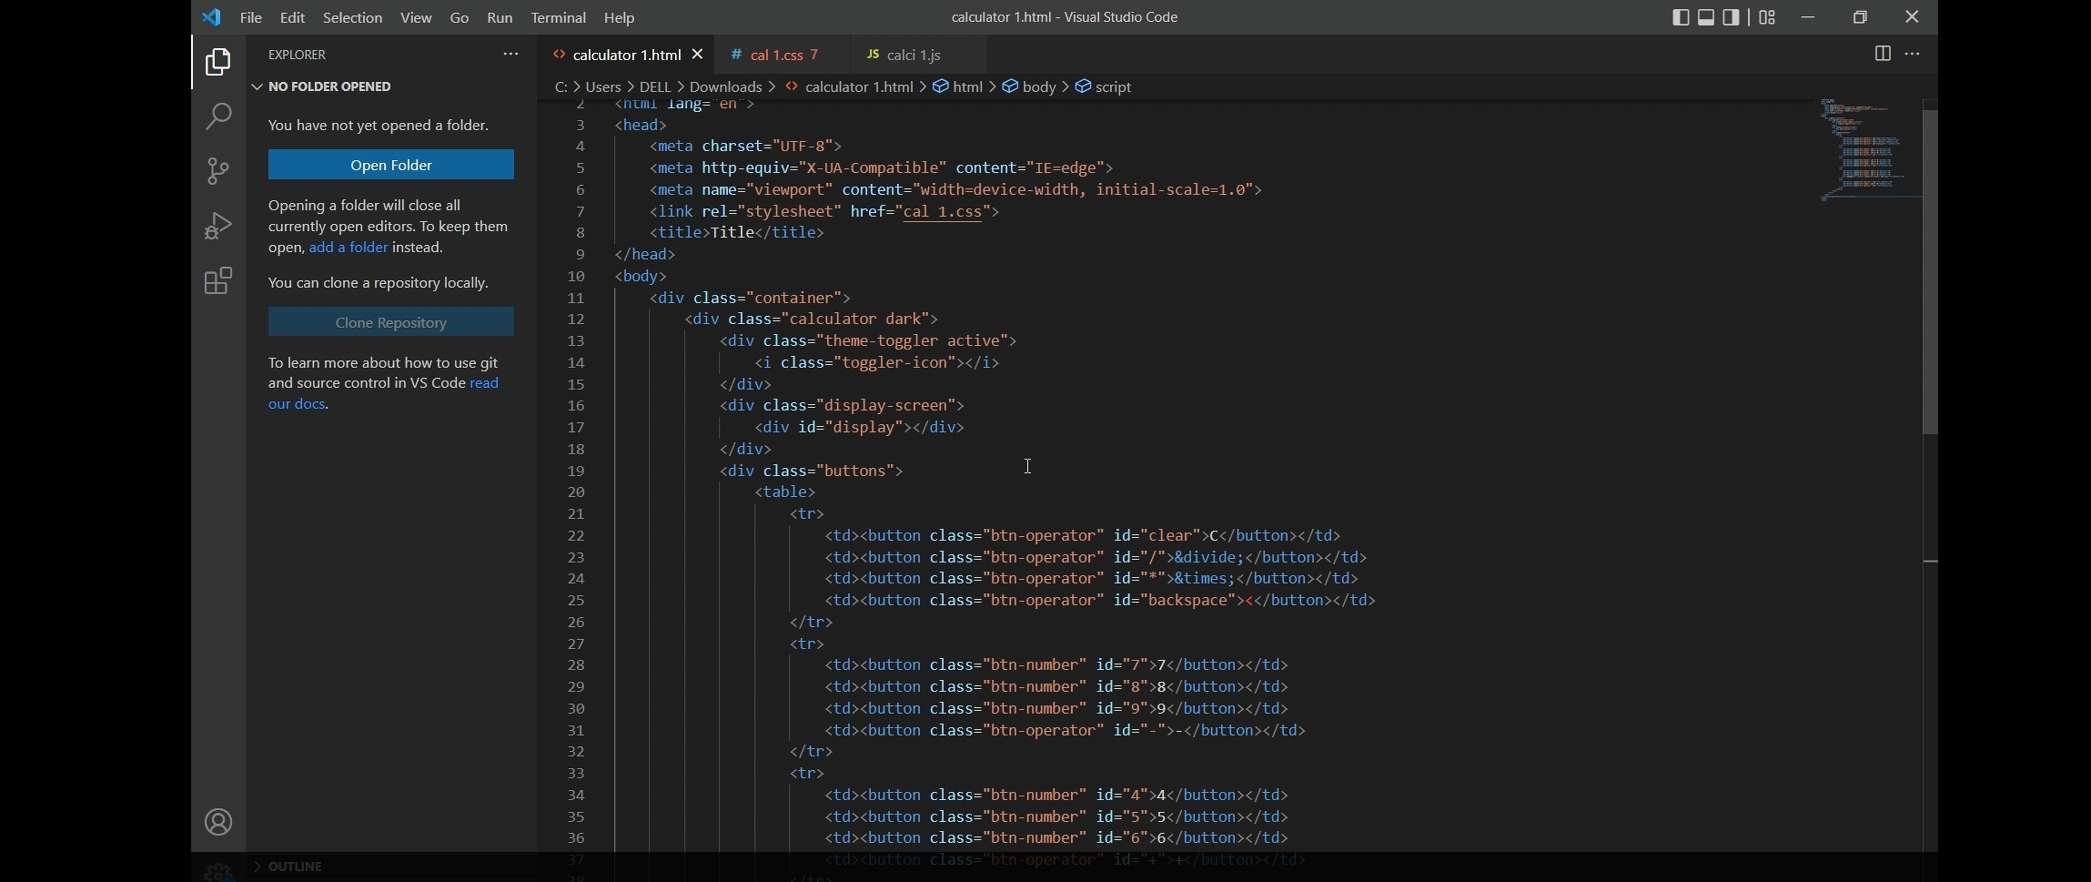

Css:-

This is a source code for giving look to site.

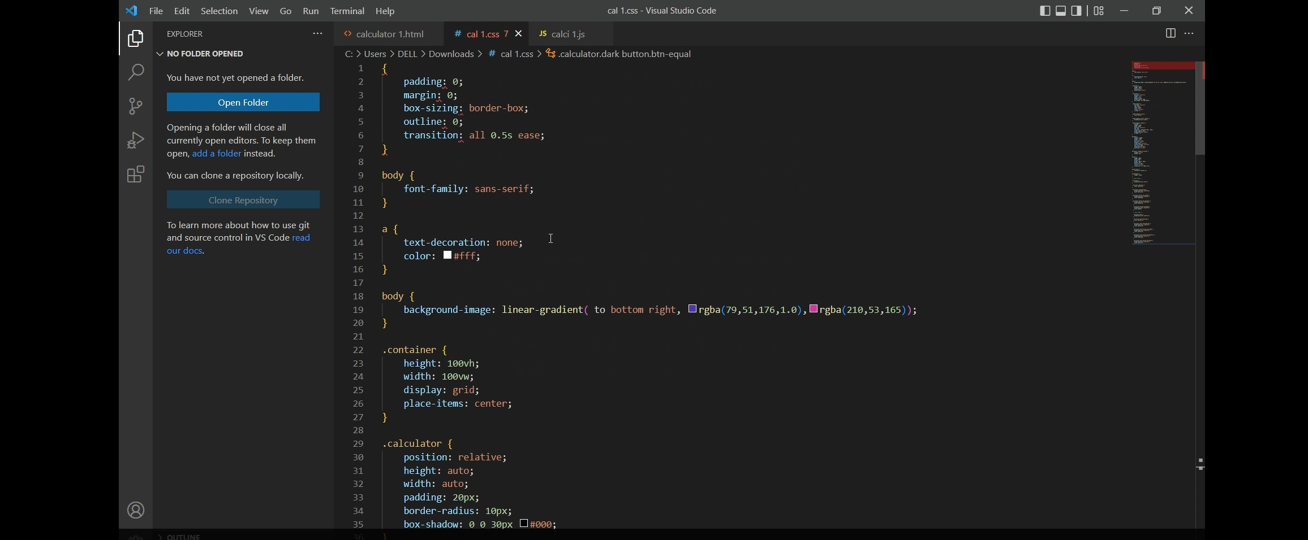

Java script:

This is what calculator is working.

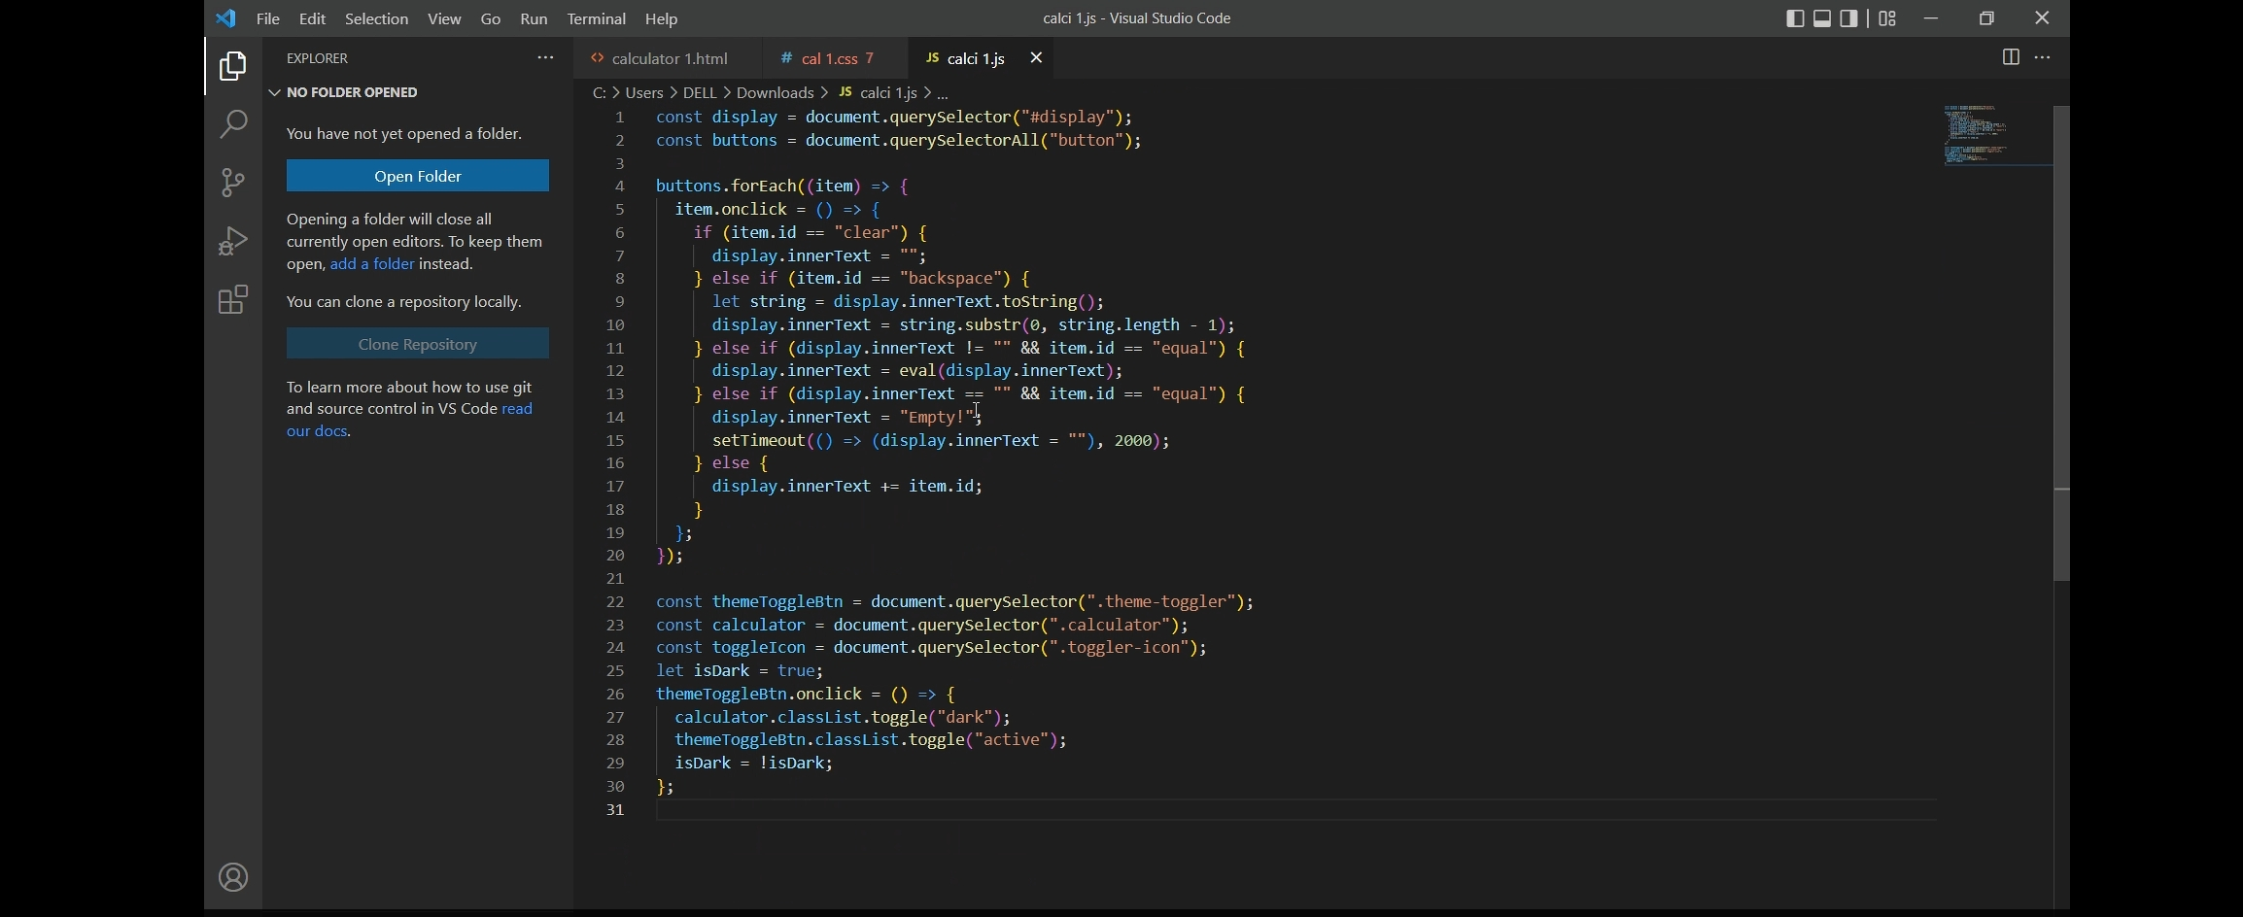

Output:-

My calculator consists of both dark and light view as shown below

